EXPERIMENT

AIM: Design an obstacle detector and distance measuring device.

APPARATUS: one Arduino Board, one breadboard, Ultrasonic sensor

CIRCUIT DIAGRAM:

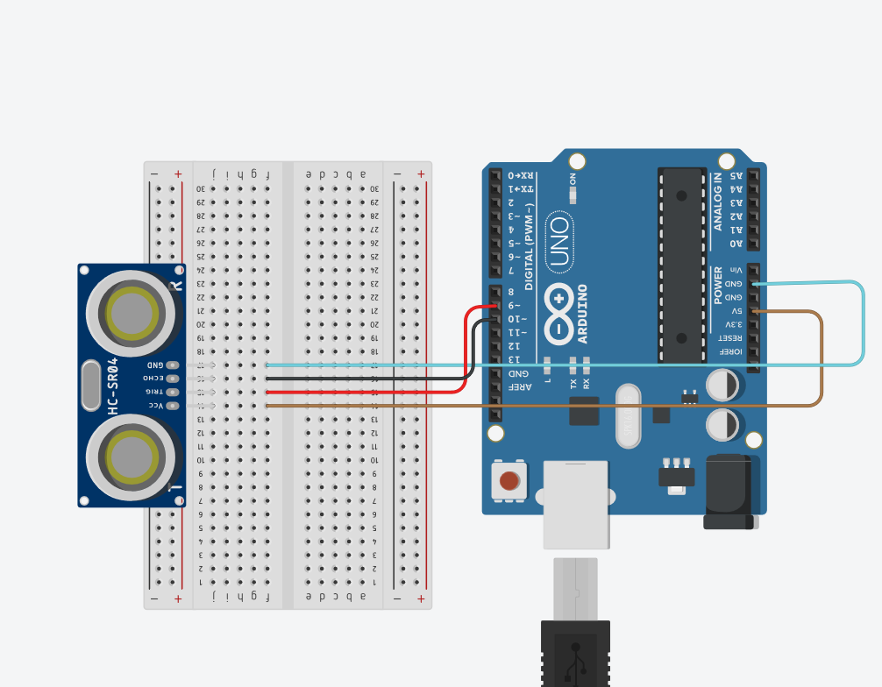

THEORY:

1. CONCEPTS USED :

-Here we have used the concepts of Ultrasonic sensor, that how we can use this device to detect the object around us.

1. LEANING AND OBSERVATION:

* An ultrasonic sensor is a device that can measure the distance to an object by using sound waves.

It measures distance by sending out a sound wave at the specific frequency and listening for that sound wave to bounce back.

* I have learned about the real life application of this device to detect distance and object near us.

PROBLEMS AND TROUBLESHOOTING:

* The device was not detecting the object near it. Then we have to detect the problem in the code and debugged it.
* Sometime the connection of the sensor was wrong due to which it was not properly working.

PRECAUTION:

1. The pins of the Ultrasonic detector should be properly connected to correct port.
2. Like the trigger pin of the Ultrasonic sensor should be in output mode and the echo pin should be input mode.

LEARNING OUTCOMES

I have learned how the waves are sent and received by sensor when object is detected and the working principle behind this. Also I have how to calculate distance.